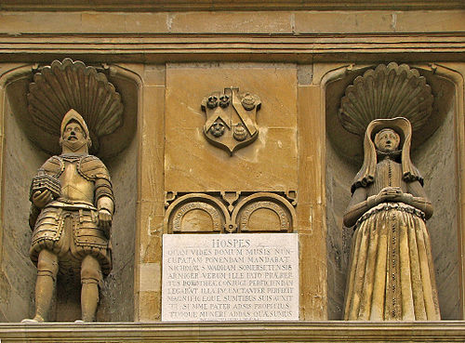
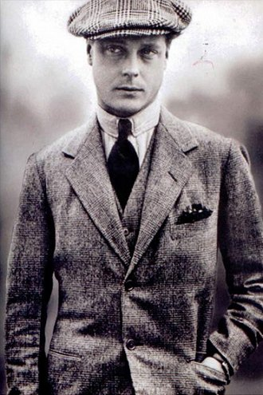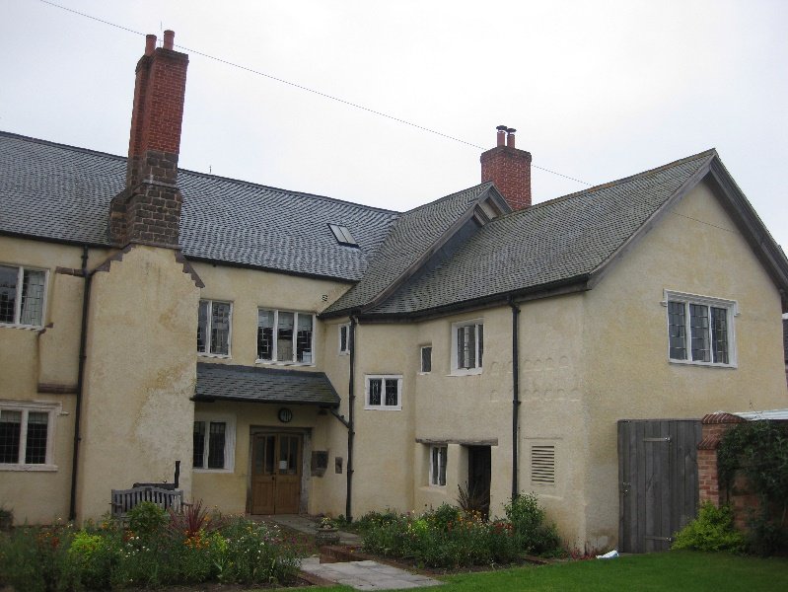
Thursday the 14th of September – Free Morning Workshop
‘Cullopmton’s Wool Trade, Coldharbour Mill and the Walronds –
A Historical Fiction Romance and Adventure Workshop’.
(9.45am registration and a 10am start. Finish at 12 o’clock.)
To book contact: cullompton.library@librariesunlimited.org.uk
Your Workshop Facilitator will be Myfanwy (Vanni) Cook, who is currently the ‘New Voices’ Feature Editor for ‘The Historical Novel Society Review Magazine’ and an Associate Fellow at two Universities. She is the author of ‘Historical Fiction Writing - A practical guide and tool-kit' and is passionate
about bringing local history alive.
www.historicalnovelsociety.org
https://twitter.com/MyfanwyCook

