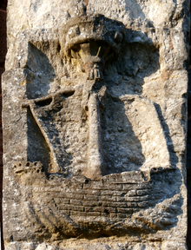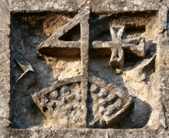
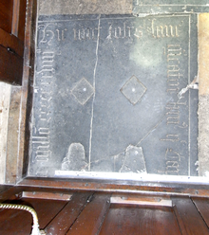
Thursday the 14th of September – Free Afternoon Workshop
The “Golgotha” and St. Andrew’s Church –A Historical Crime Fiction Workshop for those who enjoy the writing of
Ellis Peters and Umberto Eco
(1.45pm Registration and a 2pm start. Finish at 4pm.)
To book contact: cullompton.library@librariesunlimited.org.uk
Your Workshop Facilitator will be Myfanwy (Vanni) Cook, who is currently the ‘New Voices’ Feature Editor for ‘The Historical Novel Society Review Magazine’ and an Associate Fellow at two Universities. She is the author of ‘Historical Fiction Writing- A practical guide and tool-kit' and is passionate about
bringing local history alive.
www.historicalnovelsociety.org
https://twitter.com/MyfanwyCook

