BEHIND THE BOOK
Quite soon after the marriage of Kate Middleton and Prince William in April 2011, a new law was passed by Parliament, having first been endorsed by the heads of the Commonwealth nations. No longer would the order of succession to the British throne favor males over females. Now the eldest child, regardless of sex, would be heir.
When I read about this change, I had a wistful thought: might the measure be dubbed “Vicky’s law” to honor Queen Victoria’s eldest child, a girl of intelligence, energy, and commitment who was the last person passed over for the crown because she was female. All the sovereigns since Queen Victoria either had boys first, or in the case of the current queen’s father—George VI—only girls.
The poignancy of Vicky’s story has long fascinated me—perhaps because I’m the eldest in my family, and have a brother only a year younger, as she did. It was easy to imagine how painful it would be: relegated to second-best when you are first-born just because you were a “lesser”— a girl.
I also had a particular interest in the Royal Family and the late Victorian era from what my mother told me of her own mother’s childhood. My grandmother, born in 1889, grew up in Gosport, near Portsmouth, where boats departed regularly for the Isle of Wight. Her parents worked in the household of General Robert Montgomery, General Officer Commanding South Coast Defense—her mother as housekeeper and her father as coachman, later chauffeur. Royal persons could frequently be spotted passing through Gosport en route to stay at Osborne House, and we have a much-cherished photo of my great-grandfather driving King Edward VII, Vicky’s brother Bertie, and his nephew, the Kaiser, Vicky’s son. In the photo below, which dates to 1905, the King is far left, with the Kaiser beside him and Henry George Lampard, my great-grandfather, holds the reins.

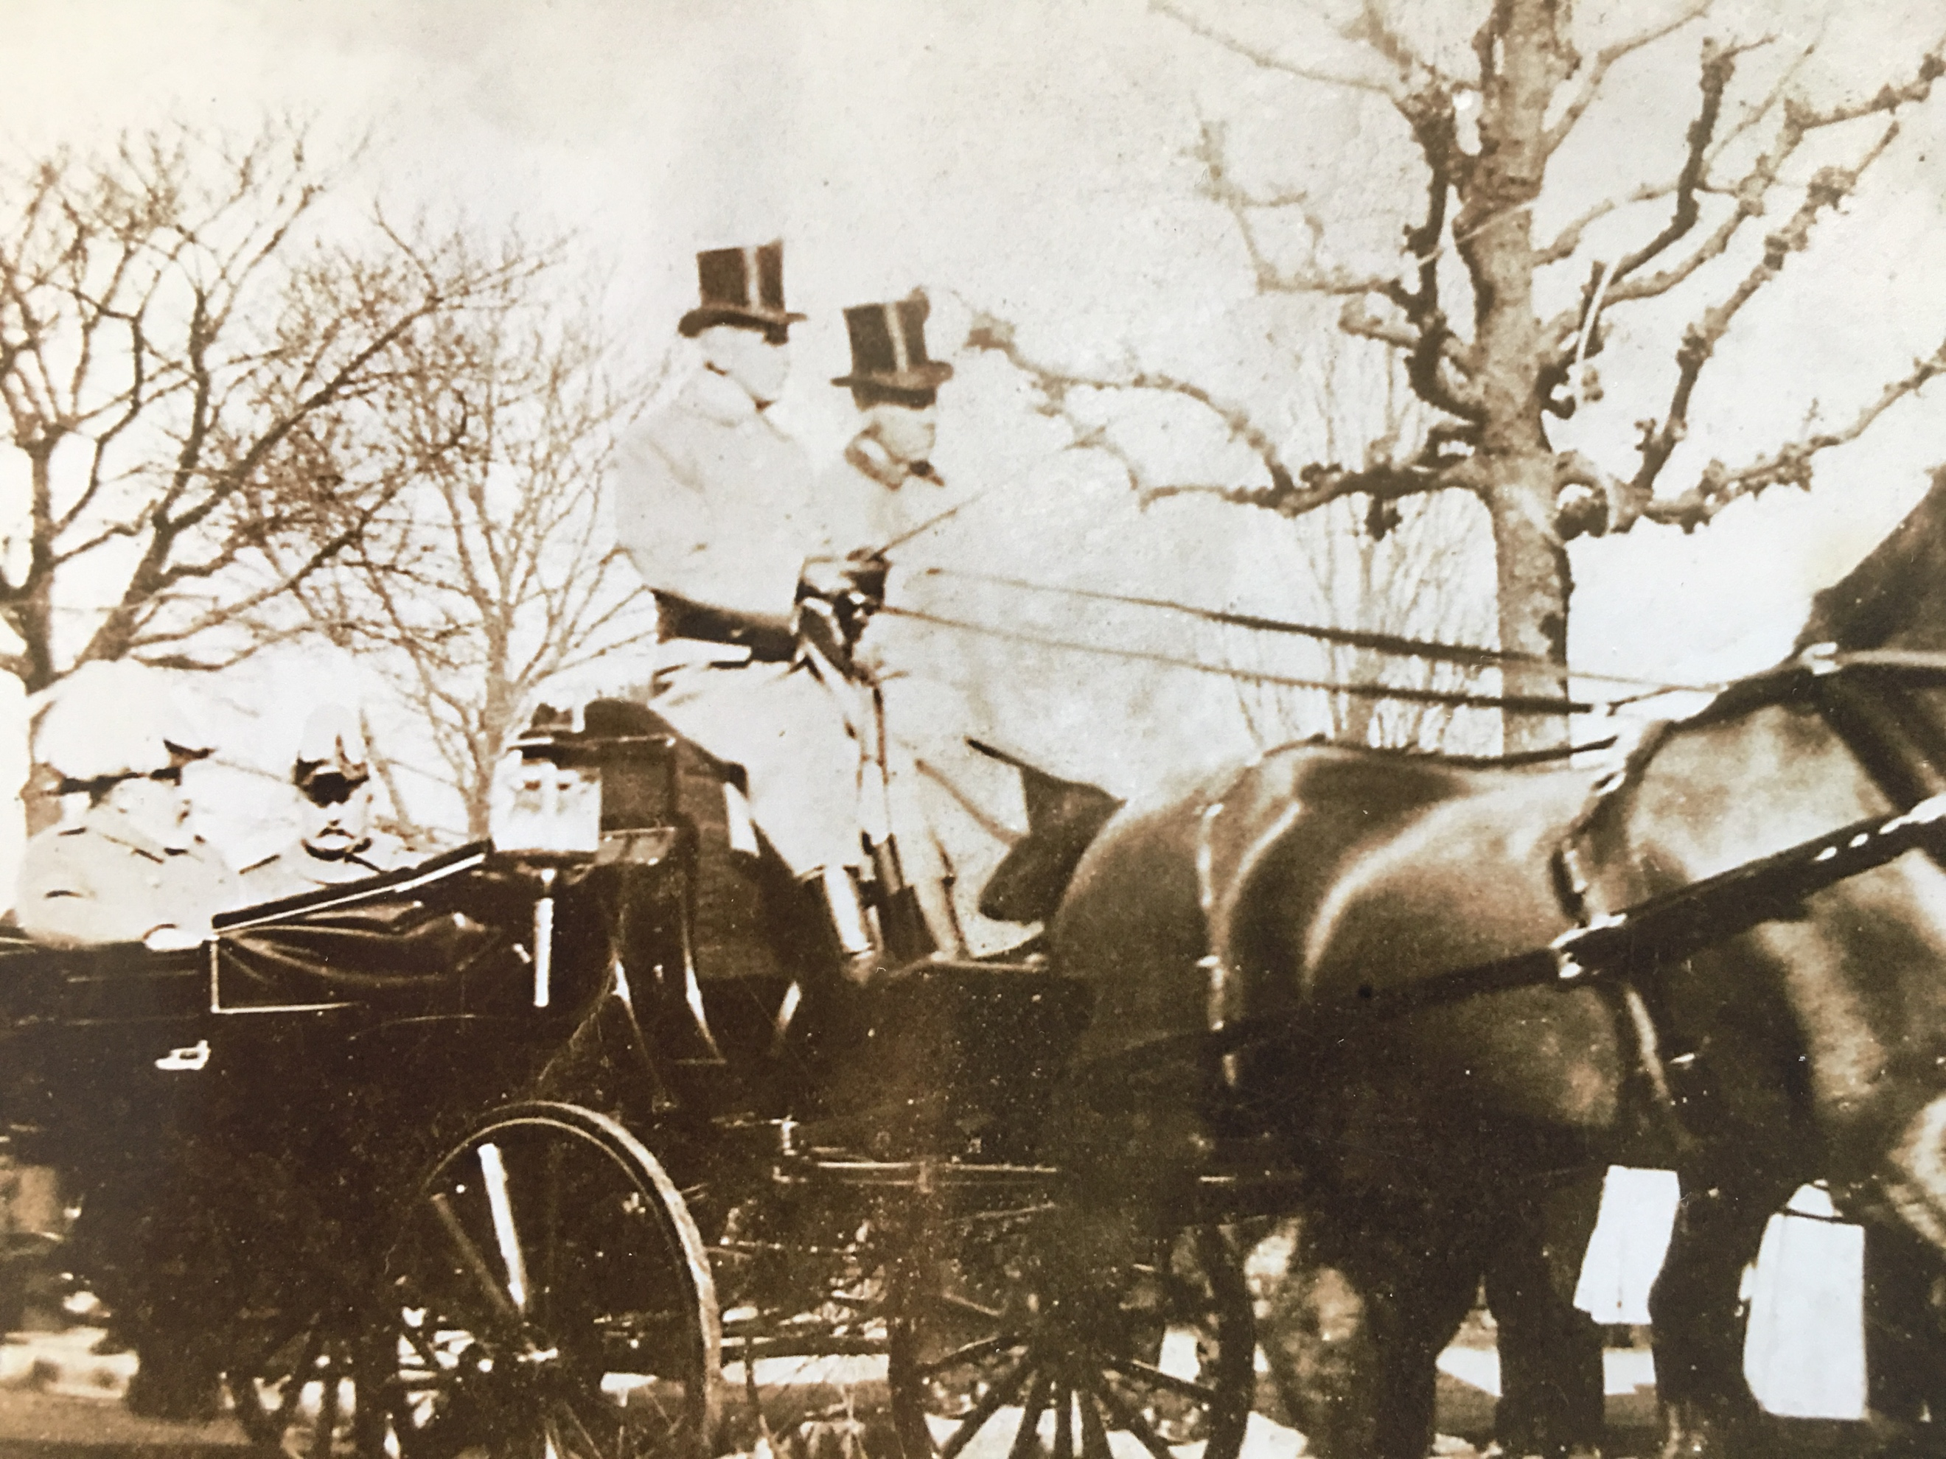

My interest in Vicky deepened in college, when I studied the rise of Germany as a nation-state, the outbreak of the First World War, the country’s tragic turn to fascism and the horrific Nazi regime. The reasons for the German descent into barbarism and genocidal madness are still debated by historians. But the seeds of later tragedy were planted in the late summer of 1862 when King Wilhelm of Prussia contemplated abdication in favor of his son Fritz, Vicky’s husband, and instead chose another path. Historian John R¨ohl writes: “We know that the King finally decided to appoint Bismarck….[but] right to the end, the struggle might easily have ended differently. We are dealing here with one of those eerie moments where history holds its breath before revealing the fate that lies in store for future generations.”
Vicky was a close witness to this hinge moment, and while I relied on imagination to conjure up the discussions between her and Fritz, her letters to Queen Victoria detail her deep distress at Bismarck’s ascendency and the choices he made for Germany in subsequent years. Going from young bride, to Crown Princess, and eventually to Empress of Germany for a scant 99 days, the Vicky I discovered in these letters is an affectionate daughter and a surprisingly modern thinker, who is determined to be the best wife, mother and public servant she can be, who rages at events outside her control, who discusses her excitement with new ideas—political, scientific, psychological. Vicky read Marx’s Das Kapital and Darwin’s On the Origin of Species with great interest. She worked tirelessly for educational opportunities for young women, and for the better care of the sick. When in the late 1870s Bismarck fanned the flames of anti-Semitism in the German Empire, she and Fritz defied their advisors to express openly their abhorrence of this invidious prejudice. Vicky accepted the honorary chairmanship of an orphanage for Jewish girls, and during the height of the anti-Semitic riots in Germany in January 1881, she accompanied Fritz, wearing his full-dress uniform as a Prussian field marshal, to services at a Berlin synagogue.
Her progressive attitudes earned Vicky the enmity of many in her adoptive country, to whom she would always be “die Englanderin,” an anti-Prussian agent of a foreign power. Bismarck’s allies encouraged rumors that she dominated her husband. For many years, Vicky stood strong against these calumnies, but the double blow of her eldest son, Willy, turning his back on his parents and joining the reactionary camp, and the illness and premature death of Fritz at age 57, just as he inherited the throne, threw her into depression for several years. The building of a new home outside Frankfurt, called Friedrichshof in Fritz’s memory (now the glamourous Schlosshotel Kronberg), revived her, as did her relationship with three of her daughters. (Charlotte and she were not close.) Her youngest son, Prince Waldemar, tragically followed Siggy to an early grave, dying of diphtheria in March 1879, at age 11, just four months after Vicky’s beloved sister, Alice, died of the same disease at her home in Darmstadt.
My awareness of all the sadness in Vicky’s life did not deter me from spending two years in her company composing this story. Her most sterling quality —her desire to be good and do good—inspired me. And the contradictions of her life intrigued me. How did this woman who was used in an archaic way—married off for dynastic and political ends—find purpose and fulfillment as an individual? How did she use her influence to shape events? What did it feel like to enjoy great privilege and yet cope with crushing disappointment? In truth Vicky often made mistakes and got in her own way. Her beloved Fritz once said her greatest flaw was over-confidence in her own opinion. But her life’s journey was a noble one, and I hope A Most English Princess will inspire readers to learn more about Vicky, and the turbulent times in which she lived.

PICTURES
- The 1846 family portrait of Franz Winterhalter hung in the dining room at Osborne House. Today it can be seen in Buckingham Palace’s East Gallery.
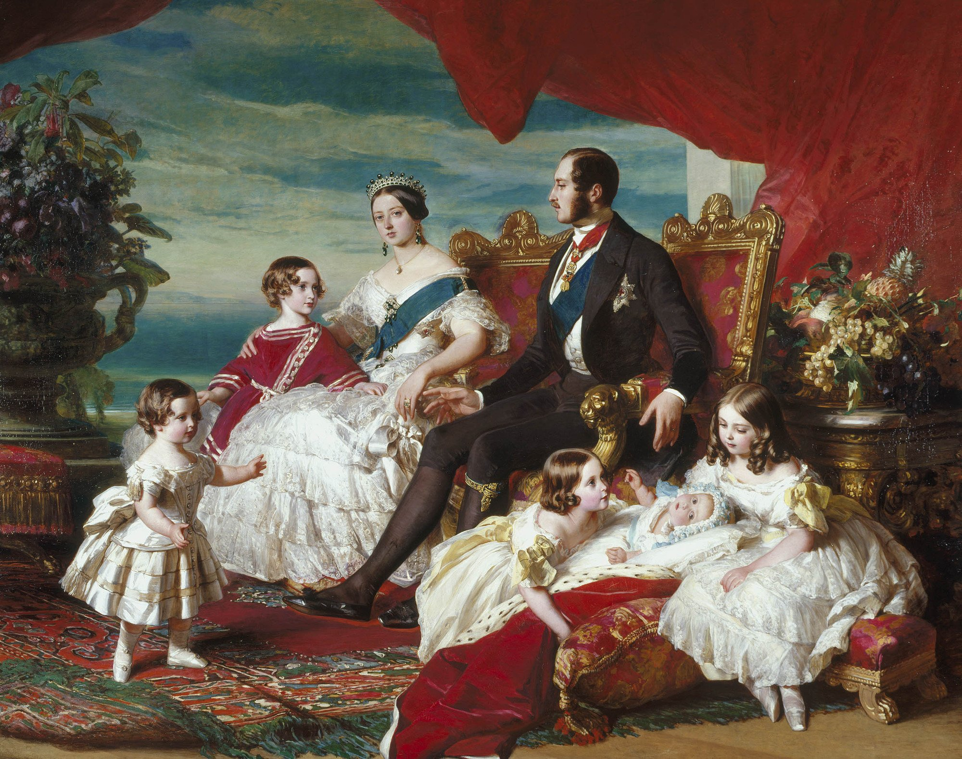

- Vicky with her parents on her wedding day, January 25, 1858
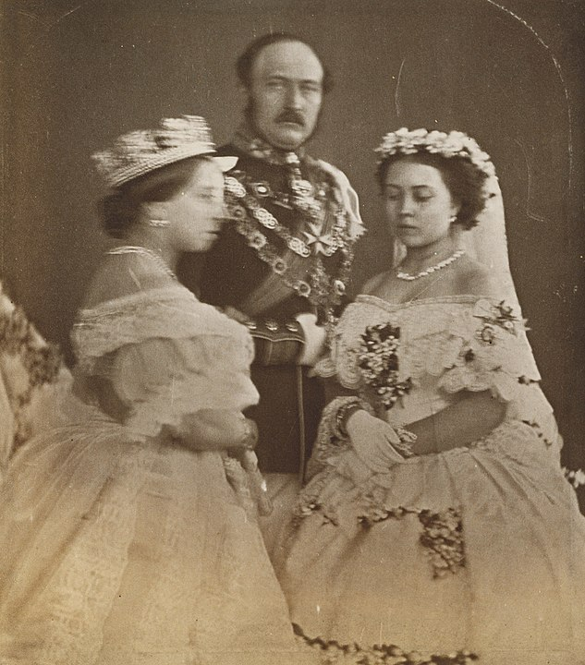

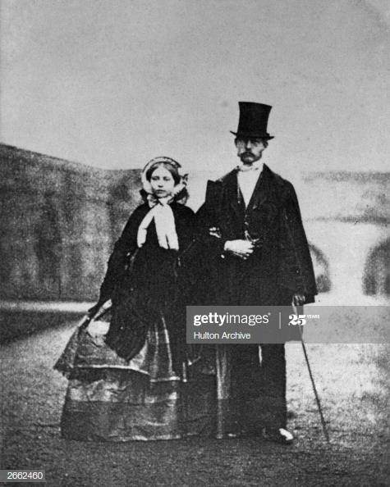

- Vicky and Fritz on honeymoon at Windsor

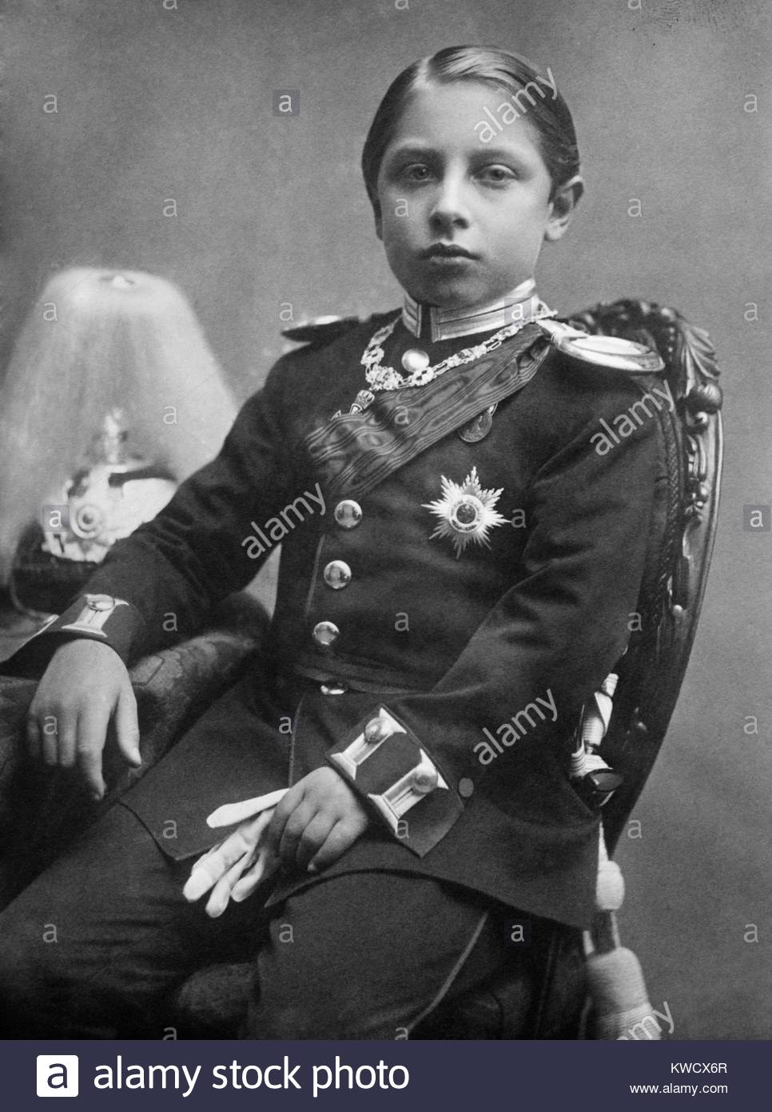
- Vicky’s eldest son Prince Wilhelm, later Kaiser Wilhelm II, as 10 year old—he’s been given gloves to hold in his left hand to lengthen the appearance of his shorter arm for the photo.

- Vicky as a widow in 1900, already ill with cancer. Kaiser Wilhelm II kept a copy of this photo in his home in exile in Doorn, the Netherlands.

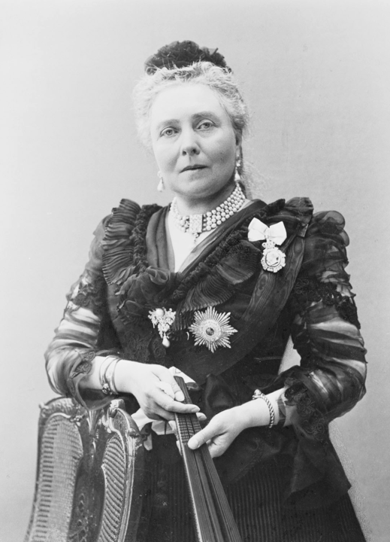

LEARN MORE
The letters between Vicky and her mother—exchanged starting immediately after Vicky’s wedding in January 1858 until January 1901, the month of Queen Victoria’s death—have been published in five volumes and they are the primary source for A Most English Princess. Kept safe by Fritz Ponsonby, the voluminous correspondence between mother and daughter today lives in two different places: Vicky’s letters to the Queen are at Windsor Castle, and Queen Victoria’s replies can be found in the archives of the Princely Hessian Family at Schloss Fasanerie near Fulda, Germany. Also, two excellent biographies of Vicky exist. The more comprehensive is the meticulously researched An Uncommon Woman, by Hannah Pakula, published in 1995. An earlier account of her life, Vicky: Princess Royal of England and German Empress by Daphne Bennett came out in 1971.
To understand the family Vicky grew up in, and the key influence of her father Prince Albert, it’s worth diving into two books by A.N. Wilson Prince Albert: The Man Who Saved the Monarchy and Victoria: A Life, both published during the last decade. There are dozens of other biographies of the famous Victoria—the classic Queen Victoria by Elizabeth Longford holds up very well fifty years after it was first published. Julia Baird’s Victoria: The Queen and Helen Rappaport’s A Magnificent Obsession: Victoria, Albert, and the Death That Changed the British Monarchy are both wonderful reads. I have enjoyed several recent film adaptions of Victoria’s life, but the lavish TV series Victoria broadcast on PBS takes too many liberties with the facts for my taste. The most historically accurate filmed account of the events covered in A Most English Princess is a 13-part BBC series first broadcast in 1974 called Fall of Eagles. You can find episodes on You Tube.
There are only academic biographies of Fritz published in English, but Bertie is the subject of a terrific book by Jane Ridley, The Heir Apparent: A Life of Edward VII, the Playboy Prince.
Vicky’s son Willy finally got the attention he deserved when Anglo-German historian John C.G. Rohl completed a magisterial three-volume life of the last kaiser in 2008. For my novel, I studied closely volume one, Young Wilhelm: The Kaiser’s Early Life 1859-1888 and was impressed by the details Rohl has gleaned from the archives, in particular the unpublished correspondence between Vicky and Fritz housed now at Schloss Fasanerie. I consider Rohl’s very critical view of Vicky’s parenting somewhat unfair. However, any reader interested in assessing what went wrong in the future kaiser’s upbringing should delve into Rohl’s book. William’s contradictory nature—his grandiosity and his warm-heartedness, his wit and his racism—is on full display in his correspondence with his childhood friend the American journalist Poultney Bigelow. The Bigelow family donated these fascinating letters and postcards to the New York Public Library, where the public can access them in the Brooke Astor Reading Room.
Otto von Bismarck has been written about—and debated, deified, misconstrued, and slandered—for decades. No other statesman in the second half of the 19th century accomplished more than Bismarck; only Abraham Lincoln, savior of the Union, comes close. And, I would aver, we are living in a world that still bears Bismarck’s fingerprints. Not only did he found Germany as a nation, he also pioneered the modern welfare state—establishing workers compensation, disability insurance, and old-age pensions in the Reich. His innovations inspired the Progressives in the Unites States, who, witnessing the industrial unrest of the 1880’s and 1890’s, believed only the Iron Chancellor had found a way to make capitalism work for everyone. Later, Franklin Roosevelt modelled the US Social Security program on the system established by Bismarck in 1889. But Bismarck— brilliant, cynical, dictatorial—ultimately played a baleful role in his country’s development. His suppression of free speech, his disregard for parliamentary authority, and his embrace of militarized monarchical autocracy, smothered liberal democracy in Germany in its infancy. Valiant Vicky didn’t live to see Berlin in ruins in 1945, but she was correct about where Bismarck’s machinations could lead. Henry Kissinger called Bismarck “The White Revolutionary” in a famous essay published in 1968. Like Lenin, Bismarck altered the society he lived in, but he did so from the right rather than the left. Along with Kissinger’s article, I recommend two excellent biographies of the Chancellor—Bismarck: A Life by Jonathan Steinberg and Bismarck by Edward Crankshaw.
The monarchy was abolished in Germany in 1918 and Vicky’s son, Willy, lived until his death in 1941 in exile in Doorn, in Holland. But today Elizabeth, Vicky’s great-grandniece, the great-granddaughter of her brother Bertie, is Queen of England. And her husband, Philip, is the great-grandson of Vicky’s beloved sister Alice. Vicky’s own descendants live all over the world—many in Germany, but others in the UK, and some in the US.
I’m a fan of New York City’s High Line park, for its amalgamation of beautiful gardens and modern urban design. A young architect named Tatiana von Preussen—Vicky and Fritz’s direct descendant, the granddaughter of their great-grandson—was part of the High Line’s design team. Strolling along the park’s wooden pathway on a sunny afternoon recently, I thought how fitting it is that Vicky who loved gardens and art and promoting the general welfare is connected in a small way to this marvelous public space. None of us know what our legacies will be, and Vicky, who strived so hard to do good, is no exception.

READING GROUP GUIDE

- Prince Albert allowed Vicky, his cherished eldest daughter, to be engaged when she not yet 15 years old, and to be married and leave home when she was 17. He pursued the Prussian marriage to serve his own political aims. Did you think his decisions concerning Vicky were selfish or well-meaning?

- Why do you think Fritz fell in love with Vicky, when he was quite a bit older than her and came from a different royal milieu? What about her made her a good wife for him?

- How much responsibility did Vicky bear for the antagonism she encountered in Berlin? Would someone with a different personality have found it easier?

- What prevents Queen Augusta and Vicky from having a strong and enduring friendship?

- Papa never anticipated Bismarck’s rise to power. Do you think he could have helped Vicky and Fritz cope with the fierce Junker leader if had he lived longer?

- What do you imagine Bismarck really thought of Vicky? He liked to complain to colleagues that she had too much influence in the royal household, and yet his associates noticed that he wanted her good opinion. Were these two strong characters doomed to be irreconcilable?

- Did Vicky give Fritz good advice when she urged him to speak out in Danzig?

- Fritz was considered a passive man in royal circles, but a brilliant and inspired leader of men in battle. Why do you imagine he felt more empowered in a military role?

- Why did Vicky cherish Siggy in particular among all her children?

- In what ways is Vicky a good mother to Willy? And in what ways did she fail him? What kind of example did Mama, Queen Victoria, set as a mother? How did Vicky’s own sense of self-worth get mixed up with her feelings about Willy?

- Do you think Vicky would have been happier with a quieter, more intellectual life than her position allowed?

- Contemporaries describe Vicky as very German when she returned to Britain, and distinctly English in Germany. To which country did she owe her first allegiance?

- Why did Vicky choose Dr. Hinzpeter to be Willy’s tutor? Do you think a different choice would have served him better?

- Vicky’s close relationship with her brother Bertie endured for her whole life despite the Danish-Prussian conflict. What does it say about both of them that they remained close confidantes?

- In the end Vicky entrusted her letters to a surrogate son, her godson, Fritz Ponsonby, rather than allow them to fall into her own son’s hands. Does that signal to you that Vicky’s life in Germany was a failure?

- In the final scene Willy takes some responsibility for the breakdown in the relationship with his mother. Who do you think bears the ultimate responsibility? Do you feel that Willy recognizes his mother for who she really was?

- What were Vicky’s greatest strengths? Her greatest weaknesses?

